WATER TECHNOLOGY
Sources of water: They are two types:
1.Surface water:
- Flowing water : ex: river , canals.
- Still water: ex: ponds , lakes.
2. Under ground water
- Spring water.
- Shallow-well water.
- Deep – well water.
3.Rain water.
4.Sea water.
Types of impurities present in water:
THEY ARE THREE TYPES
1.Dissolved impurities:
Ca[HCO₃]₂ , CaCl₂ , CaSO₄.
Mg[HCO₃]₂ , MgCl₂ , MgSO₄.
2.Suspended impurities :
Ex: sand , clay , etc ..
3.Microscopic impurities:
Ex : bacteria , virus , fungus , etc.
- Soft water: The water which gives lather easily with soap is called soft water
ex: rain water.
- Hard water: The water does not gives lather easily with soap is called hard water.
Ex: sea water
Types of hardness of water:
- Hardness: The lather preventing property of soap with water is called hardness:
They are two types:
1.Temporary hardness: The hardness is due to the presence of bi-carbonates of calcium and magnesium is called temporary hardness . It can be removed by boiling.
Ex: Ca[HCO₃]₂ , Mg[HCO₃]₂ , etc.
2. Permanent hardness: The hardness is due to the presence of chlorides and sulphates of calcium and magnesium is called permanent hardness . It cannot remove by boiling.
Ex: CaCl₂ , CaSO₄
MgCl₂, MgSO₄ , etc…
- Names and formulae of salts responsible for temporary hardness and permanent hardness:
Temporary hardness:
Ex:
- Ca[HCO₃]₂ Calcium bicarbonate.
- Mg[HCO₃]₂ Magnesium bicarbonate.
- Permanent hardness:
Ex:
- CaCl₂ Calcium chloride.
- MgCl₂ Magnesium chloride.
- CaSO₄ Calcium sulphate.
- MgSO₄ Magnesium sulphate
Disadvantages of hard water used in industries:
- Paper industry: If the hard water used in paper industry , then the quality of paper decrease.
- Sugar industry: If the hard water used in sugar industry then the quality of sugar decrease.
- laundry industry: If the hard water used in laundry industry then the large amount of soap is wasted.
- Boiler industry: if the hard water used in boiler industry then the life time of boiler decrease.
- Pharmaceutical industry: If the hard water used in pharmaceutical industry then may produce certain undesirable products.
- Dyeing industry: If the hard water used in dyeing industry then the colours will be faded with in short period of time.
- Degree of hardness: The amount of hardness producing salts present in water is called degree of hardness.
Degree of hardness =Wt of salt x 100
G.M.Wt of salt
Units:
- ppm (parts per million)
- mg\l (milligram per litre)
- ºFr (french degree)
- ºCl (clarke’s dregree)
Relation:
“1”ppm=“1” mg\l = 0.1 ºFr = 0.07 ºCl
Softening methods of hard water:
- Softening: The process of removal of hardness producing salts present in water is called softening.
They are two types:
- Zeolite (or) permutit process .
- Ion –exchange process.
Zeolite (or) permutit process:
- Zeolite: The sodium aluminum ortho silicate is called zeolite (or) permutit.
Formula: Na₂Al₂Si₂O₈xH₂O Zeolite(or) permutit.
(or)
Na₂Z , Where Z=Al₂Si₂O₈xH₂O
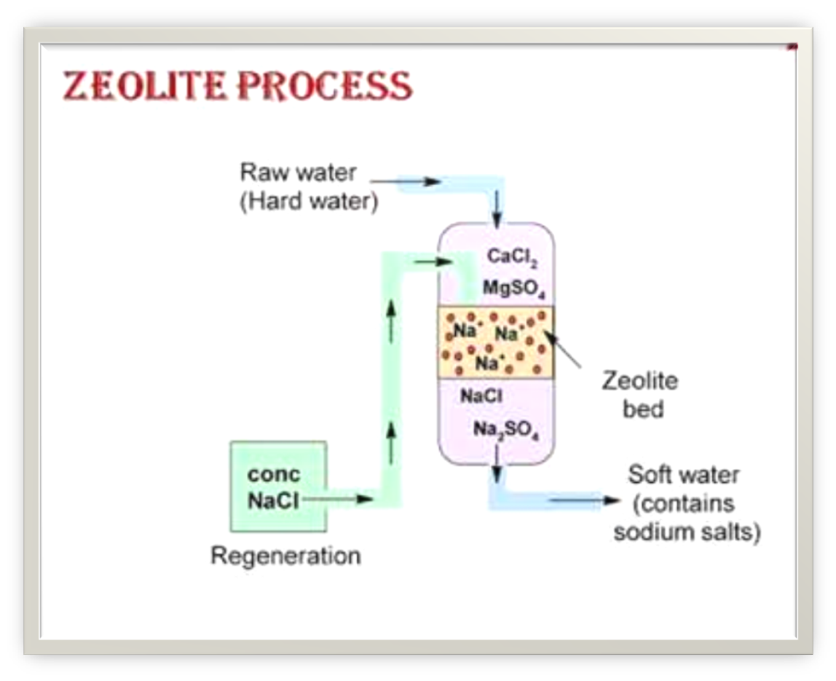
EXPLANATION:
- In this method there is a vertical vessel . In the center of vessel there is a filtre bed which is filled with zeolite.
when the hard water is passed from top of vessel then cailcum and magnesium salts present in hard water are absorbed by zeolite . The water which comes from bottom of vessel is called soft water.
- REACTIONS:
- CaSO₄ +Na₂Z CaZ+Na₂SO₄
2. MgSO₄ +Na₂Z MgZ +Na₂SO₄
- CaCl₂ + Na₂Z CaZ + 2 NaCl
- MgCl₂ + Na₂Z MgZ + 2NaCl
- Regeneration: This can be done by passing 10% NaCl solution (brine solution).
- CaZ + 2NaCl Na₂Z +CaCl₂
- MgZ + 2NaCl Na₂Z + MgCl₂
CaCl₂ ,MgCl₂ are removed by washing.
Ionic – exchange process:
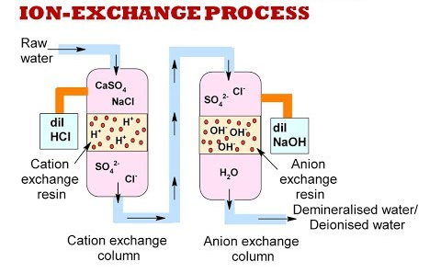
Explaniation:
- In this method there are two vertical vessels. The first vessel is called cation exchanger , Which is filled with acid resin (R –COOH). The second vessel is called anion exchanger , which is filled with base resin (R-OH).
REACTIONS:
- Step-1: when the hard water is passed through the cation exchanger then the cations like Ca²⁺ , Mg²⁺ , etc… are exchanged by R-COOH.
Ca²⁺ + 2R-COOH (R-COO)₂Ca + 2H⁺
Mg²⁺ +2R-COOH (R-COO)₂Mg +2H⁺
- Step-2: Now , the water is passed through anion exchanger then the anions like SO₄²⁻ , Cl⁻ , etc ….are exchanged by (R-OH).
SO₄²⁻ +2R-OH R₂-SO₄ +2OH⁻
Cl⁻ +R-OH R-Cl +OH⁻
- Step-3: The H⁺ and OH⁻ ions combined to form soft water.
H⁺ + OH⁻ H2O
REGENERATION:
- The cation exchanger can be regenerated by passing dilute HCl.
(R-COO)₂Ca +2HCl 2R-COOH + CaCl₂.
(R-COO)₂Mg + 2HCl 2R-COOH + MgCl₂.
- The anion exchanger can be regenerated by passing dilute NaOH.
R₂-SO₄ + 2NaOH 2R-OH +Na₂SO₄.
R-Cl +NaOH R-OH +NaCl.

Essential qualities of drinking water:(portable water)
- It should be colourless and odour less.
- It should be free from suspended impurities.
- It should be free from harmful salts.
- It should be free from dissolved gases like CO₂ , H₂S, etc…
- It should be free from toxic metals like Pb , Hg , etc..
- It should be free from micro organisms.
- The P^{H} of water should be between 7 and 8.
- The flouride content must be less than 2 ppm.
Osmosis: The process of transfer of solvent from low concentrated region to high concentrated region through a semipermeable membrane is called osmosis.
Ex: plants absorb water from soil
- R.O[reverse osmosis]:The process of transfer of solvent from high concentrated region to low concentrated region through a semipermeable membrane is called reverse osmosis.
Ex: The sea water is converted in to drinking water.
- Applications of R.O:
1.It can be used for sea water purification.
2.It can be used for rain water purification.
3.It can be used for drinking water purification.
4. It is used in the dialysis process.
5. It is used to remove ionic, non-ionic and organic impurities.
6.This process is cheap in cost and easily carry out.
7. It does not involve heating process.
R.O Process :
- R.O is used to obtain drinking water from the sea water.
- The sea water and pure water in a container are separated by a semipermeable membrane.
- If high pressure is applied on sea water then the pure water passed through the semipermeable membrane.
- If salts or impurities left over in that part only then the pure water gradually taken out.
- The semipermeable membrane is made up of thin films of cellulose acetate.
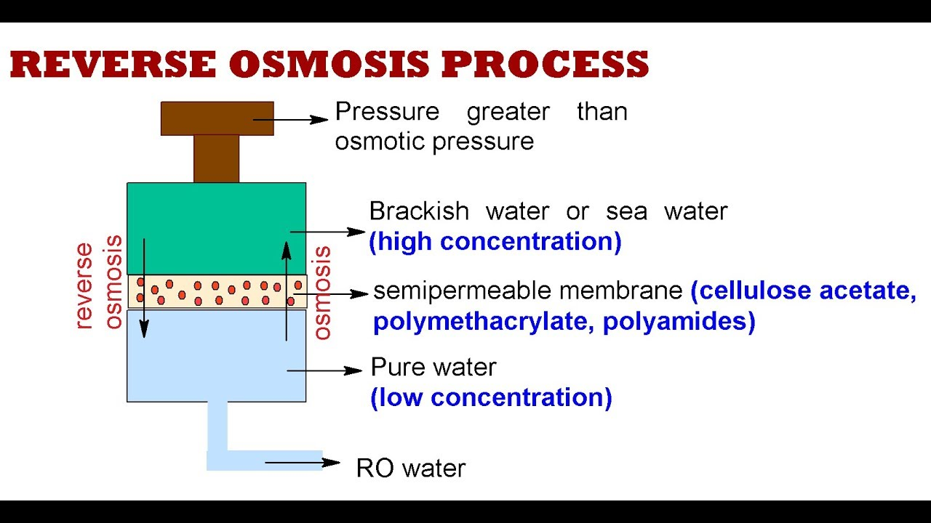
Problems:
  - Formulae:
1.Temp.Hardess= Wt x100
G.M.Wt
2.Per.hardness = Wt x100
G.M.Wt
Note:

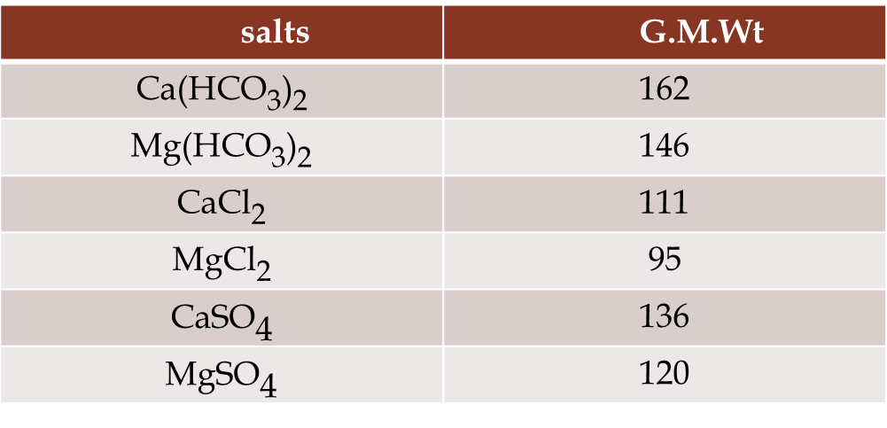
- A sample of water contains 6gm MgSO₄ per 100kg of water . What is degree of hardness?
Solution: degree of hardness= ?
wt.of MgSO₄ =6gm
G.M.Wt of MgSO₄ = 120gm
wt.of water = 100kg = 100 x 1000 = 10⁵gm
degree od hardness = wt.of salt x 100 x 10⁶
G.M.Wt wt.of water
= (6/120) x (100/ 10⁵ ) x 10⁶
= 50ppm.

