CORROSION
- Rust: The oxide form of a metal is called rust
Ex: Fe₂O_{3 ,} Cu₂O , Ag₂O , etc….
- corrosion: The slow and gradual disintegration of a metal due to the effect of atmosphere is called corrosion.
Factors influencing the rate of corrosion: The following factors influencing the rate of corrosion.
- Purity of metal: If the metal is in impure state then the rate of corrosion will increase.
- Physical state of metal: If the metal is rough surface then the rate of corrosion will increase.
- Humidity of air: It has high percentage of humidity then the rate of corrosion will increase.
- Temperature: If the temperature of metal is high then the rate of corrosion will increase.
- P^{H}: The rate of corrosion is more acidic media (P^{H}<7) than alkali (or) neutral media.
- Impurities present in atmosphere: The presence of corrosion gases like HCl , H₂SO₄ , CO₂ , SO₂ , H₂S , etc…., increases the rate of corrosion.
- Position of metal in electro chemical series: if the metal is top in electro chemical series then the rate of corrosion will increase.
TYPES OF ELECTRO CHEMICAL CELLS:
- They are three types:
- 1. Composition cell
- 2. concentration cell
- 3. stress cell

Composition cell:

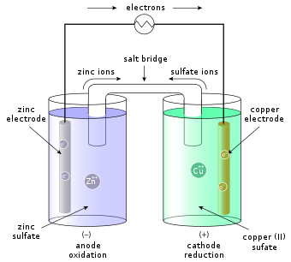
1.Composition cell: A cell which is formed between two different metals is called composition cell
one metal is taken as top in electro chemical series acts as anode and under goes corrosion. The other metal is taken as lower in electro chemical series acts as cathode.
2. Concentration cell: A cell which is formed between concentrated area and un concentrated areas of a metal is called concentrated cell.
The concentrated area acts as anode and undergoes corrosion . The un concentrated area acts as cathode.
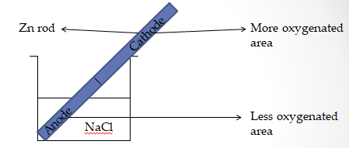
Reactions:
- At anode: Zn Zn₂+ + 2e⁻ (oxidation)
- At cathode: 2e⁻ + (1/2)O₂ + H₂O 2OH⁻ (reduction)
- Zn²⁺ + 2OH⁻ Zn(OH)₂
3. Stress cell: A cell which is formed between stressed area and un stressed areas of a metal is called stress cell.
The stressed area acts as anode and undergoes corrosion .The un stressed area acts as cathode.
EX:
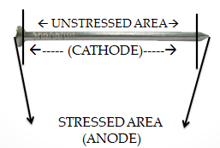
RUSTING OF IRON WITH MECHANISM:
When iron metal is left in open air for a long time then reddish brown precipitate form on the surface of iron metal is called rusting of iron.
2Fe(OH)₃ Fe₂O₃ . X(H₂O)
|(rusting of iron)|where X=0 to 3
Necessary conditions:
1.Moisture
2.O₂ and CO₂
3.Temperature
4.P^{H}
5.Impure state of metal
Mechanism:
The iron metal loss of electrons and forms Fe₃⁺ ion.
2Fe 2Fe³⁺ + 6e- (oxidation)
2. The electron released form iron metal reacts with O₂ and water vapour to form OH⁻
6e- + (3/2)O₂ + 3H₂O 6OH⁻ (reduction)
3. The Fe³⁺ combines with 6OH⁻ to form Fe(OH)₃
2Fe³⁺ + 6OH⁻ 2Fe(OH)₃
4. The Fe(OH)₃ loss of water and forms Fe₂O_{3.}XH₂O
2Fe(OH)₃ Fe₂O_{3.}XH₂O
|(rusting of iron)|where X= 0 to 3
Corrosion control methods:
- They are two types
- Protective coatings.
- Cathodic coating
- Protective coating : they are three types
- Metallic coating
- Non-metallic coating
- Organic coating
Metallic coating:
- These are two types
- Anodic coating: The more active metal is coated on base metal is called anodic coatings.
Ex: “Zn” coating on “Fe” (galvanisation)
- Cathodic coating: The less active metal is coated on base metal is called cathodic coating
Ex: “Sn” coating on “Fe” (tinning)
Non-metallic coatings:
- They are 3 types
- Phosphate coatings
- Chromate coatings
- Oxide coatings
Organic coatings: The organic compounds like paints , enamels , varnishes and plastics coated on base metal is called organic coatings.
DIFFERENCE BETWEEN ANODIC COATING AND CATHODIC COATING:
Anodic coating | Cathodic coating
1.The more active metal is coated on base metal is called anodic coatings. | 1.The less active metal is coated on base metal is called cathodic coating
2.Ex: “Zn” coating on “Fe” (galvanisation) | 2.Ex: “Sn” coating on “Fe” (tinning)
3. The reactivity of coated metal is more than base metal | 3. The reactivity of coated metal is less than base metal
4. The electrode potential of coated metal is less than base metal | 4. The electrode potential of coated metal is more than base metal
5. The base metal is not corroded when cracks developed in the surface coating | 5. The base metal is corroded when cracks developed in the surface coating
- Cathodic protection: The iron metal to be protected from corrosion is made cathode by connecting with more active metal (or) external voltage through insulate copper wire is called cathodic protection .
- They are two types
- Sacrificial anodic method
- Impressed voltage method
Sacrificial anodic method:
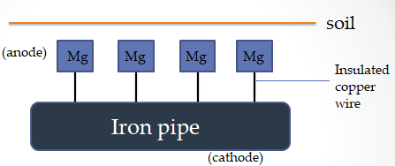
- Explanation :
- The iron metal to be protected from corrosion is made cathode by connecting with more active metal through insulated copper wire
- The more active metal act’s as anode and undergoes corrosion. Thus , the iron metal is protected from corrosion .
- . The more active metal is also known as sacrificial anode.
- Some sacrificial anodes commonly used are Zn , Al , Mg , etc…..
- Uses:
- This method is used to protect the underground iron pipes.
- This method is used to protect the underground cables , water tanks , etc…..
Impressed voltage method:
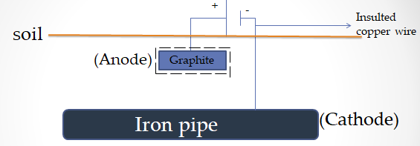
- Explanation:
- The iron metal to be protected from corrosion is made cathode by connecting with more active metal and external voltage through insulated copper wire
- The external voltage is applied in opposite direction to nullify the corrosion current from anode to cathode
3. The more active metal using graphite acts as anode . Thus , the iron metal is protected from corrosion.
- Uses:
- This method is used to protect the underground iron pipes , high power transmission towers , large constructions , etc….
- This method is used to protect the water tanks , condensers .

