Electro chemistry
- Conductor : A substance which can allow the flow of electric current is called conductor .
Ex: all metals , alloys , etc…
- Insulator: A substance which can not allow the flow of electric current is called insulator.
Ex: wood, Paper , Plastic ,etc..
- Types of conductors: They are 2 types
- Metallic Conductors: A conductor in which the electrons are carrying the current is called metallic conductors
Ex: All metals, alloys ,etc…
- Electrolytic Conductors: A conductor in which the ions are carrying the current is called electrolytic conductors .
Ex: all acids, bases, salts , etc…
- Electrolyte: A substance which can decomposes into ions by the passage of electric current in molten state (or) aqueous solution is called electrolyte.
Ex: all acids , bases, salts , etc..
- Non-electrolyte: A substance which cannot decomposes into ions by the passage of electric current in molten state (or) aqueous solution is called non-electrolyte.
Ex: glucose , sugar , urea , benzene , etc…
Types of electrolyte:
- They are two types
- Strong Electrolyte: A substance which can decomposes fastly into ions by the passage of electric current in molten state (or) aqueous solution is called strong electrolyte.
Ex: all strong acids , bases, salts , etc..
- Weak Electrolyte: A substance which can decomposes slowly into ions by the passage of electric current in molten state (or) aqueous solution is called strong electrolyte.
Ex: all weak acids , bases, salts , etc..
Distinguish between metallic conduction and electrolytic conduction:
Metallic conduction | Electrolytic conduction
1. In this electrons are carrying current | 1. In this the ions are carrying current
2. Ex: all metals , alloys , etc.. | 2. Ex: all acids , bases , salts , etc..
3.In this , the electrons moves from negative end to positive end | 3. In this , the ions moves towards the oppositely charged electrodes
4. In this , no chemical reactions takes place | 4.In this , chemical reactions takes place
5. In this , no flow of matter | 5. In this flow of matter.
Electrolysis of fused(molten) NaCl:
- Electrolysis: the process of decomposition of an electrolyte into ions by the passage of electricity is called electrolysis.
Ex: electrolysis of fused NaCl
- Anode: platinum rod
- Cathode: platinum rod
- Electrolyte: fused NaCl
- Reactions:
- Ionisation: NaCl ⇌ Na⁺ + Cl⁻
- At anode: 2Cl⁻ Cl₂ (↑) + 2e⁻ (oxidation)
- At cathode: 2Na⁺ + 2e⁻ 2Na (reduction)
Note: The chemical equivalent of an electrode
E = At.wt(M) / valency(n)
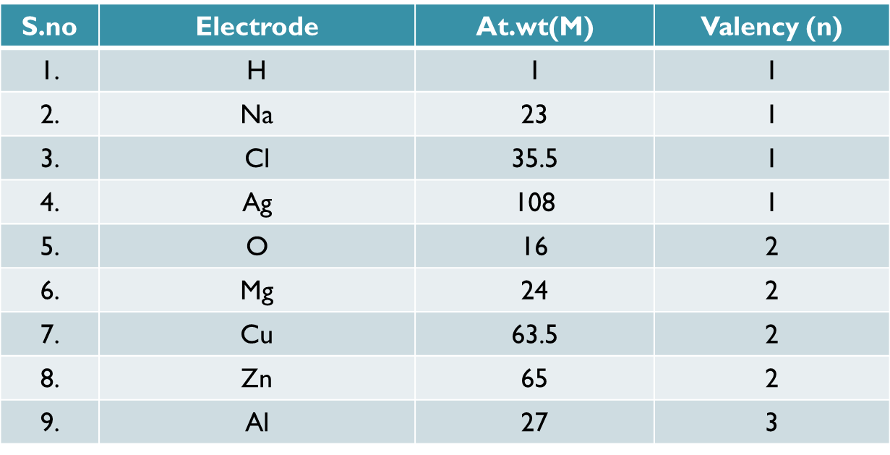

FARADAY’S LAW OF ELECTROLYSIS:
- Faraday’s 1st law : “The weight of the substance deposited at electrode is directly proportional to the quantity of electricity passed through the electrolyte” is called faraday’s 1st law .
i.e, W ∝ Q
W ∝ (ct)
w = ect
Where, w = weight of the substance deposited at electrode
e= electro chemical equivalent
c = current in amperes
t = time in seconds
- Electro chemical equivalent (e) : The weight of substance deposited at electrode by passing 1 coulomb of electricity per 1 second is called electro chemical equivalent .
Faraday’s 2st law : “when the same quantity of electricity is passed through two (or) more electrolytes then the weight of the substances deposited at electrodes are directly proportional to their chemical equivalents” is called faraday's second law.
- i.e, W₁ / E₁ = W₂ /E₂.
- where, W_{I} = weight of the 1st element
E_{I} = chemical equivalent of 1st element
W₂= weight of the second element
E₂ = chemical equivalent of 2nd element
Faraday:
- The quantity of electric current carried by 1mole of electrons (i.e, 6.023 x 10²³ ) is called faraday.
F= Ne
F= 6.023 x 10²³ x 1.602 x 10⁻¹⁹
F =96,500 coulombs
RELATION BETWEEN ELECTRO CHEMICAL EQUIVALENT (e) AND CHEMICAL EQUIVALENT (E):
- Electro chemical equivalent (e) : The weight of substance deposited at electrode by passing 1 coulomb of electricity per 1 second is called electro chemical equivalent.
- e = M/n.F 1
- Chemical equivalent (E): The weight of substance deposited at electrode by passing 1 Faraday (F=96,500 coulombs ) of electricity per 1 second is called chemical equivalent.
E = M /n 2
- From eq1
e = M/n.F
= (M/n)(1/F)
= E . (1/F)
e = E/F
Formulae:
- W = MCt/nF
- C=WnF/Mt
- t=WnF/MC
- Faraday’s 1st law : W=eCt
- Faraday’s 2nd law : W₁ / E₁ = W₂ /E₂.
Problems:
- Model-1
- Calculate the weight of copper deposited when 10amperes of current is passed through a solution of CuSO₄ for 10min?
Solution:
Given that,W=?
Current(C) =10amp
Time (t)=10min=10x60=600sec
Given that, CuSO₄
Atomic weight(M)=63.5
Valency(n)=2
Faraday(F)=96500Coulombs
Since
W=MCt/nF
=(63.5x10x600)/(2x96500)
=1.974gm
The Weight of Copper Deposited(W)=1.974gm
- Model-2
  - Calculate the current required in amperes to deposit 0.01gm of Zn in 1min 40 sec?
Solution:
Given that, C=?
Weight(W)=0.01gm
Time(t)=1min 40sec
=60+40=100sec
Given that,Zn
Atomic weight(M)=65
Valency(n)=2
Faraday(F)=96500coulombs
Since
C=WnF/Mt
=(0.01x2x96500)/(65x100)
=0.296amp
The required current is 0.296amp
- Model-3
- How long would it taken to deposit 18gm of Al from an electrolytic cell containing Al₂O₃ using a current of 20amp?
Solution:
Given that , t=?
Weight(W)=18gm
Current (C)=20amp
Given that Al,
atomic weight (M)=27
Valency(n)=3
Faraday(F)=96500Coulombs
Since
t=WnF/MC
=(18x3x96500)/(27x20)
=9650sec
The required time =9650sec
- Model-4
- A current of 2amp passing through AgNO₃ Solution per 10min,deposits 1.4292gm of silver. What is the electro chemical equivalent of silver?
Solution:
Given that,e=?
weight(W)=1.4292gm
current(C)=2amp
time(t)=10min=10x60=600sec
Since Faraday’s 1st law
W=eCt
e=W/Ct
=1.4292/(2x600)
=1.191x10⁻³gm/coulombs
e =1.191x10⁻³gm/coulombs
- Model-5
- Calculate the weight of copped deposited from CuSO₄ Solution , of 5.4gm of silver deposited from AgNO₃ Solution by the same current ?[A.wt of Cu=63.5,At.wt of silver=108]
solutions:
Given that: CuSO₄
The weight of copper(W₁)=?
Chemical equivalent of copper(E₁)=M₁/n₁
=63.5/2
=31.75gm
Given that , AgNO₃
The weight of silver(W₂)=5.4gm
Chemical equivalent of silver(E₂)=M₂/n₂
= 108/1
= 108gm
Since , faraday’s second law
W₁/E₁ = W₂/E₂
W₁=(W₂XE₁)/E₂
= (5.4X31.75)/108
= 1.5875gm
The wt.of copper (W) = 1.5875gm
Galvanic cell (or) voltaic cell:
- A cell in which the chemical energy is converted to electric energy is called galvanic cell.
- Construction :
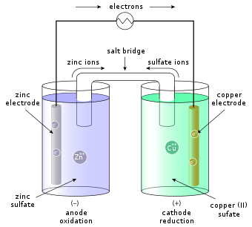
Explanation :
- The galvanic cell contains two u-shaped beakers.
- The first beaker containing Zn rod inserted into ZnSO₄ solution which acts as anode.
- The second beaker containing Cu rod inserted into CuSO₄ solution which acts as Cathode.
- The anode & cathode connected through a voltmeter
- The ZnSO₄ and CuSO₄ solutions are seperated by a salt bridge.
- The salt bridge is a u-shaped tube containing agar-agar gel with saturated KCl
- The salt bridge prevents the physical mixing of two solutions.
Working:
- At anode : Zn Zn²⁺ + 2e⁻(oxidation)
- At cathode: Cu²⁺ +2e⁻ Cu(reduction)
- Net reaction: Zn + Cu²⁺ Zn²⁺ + Cu
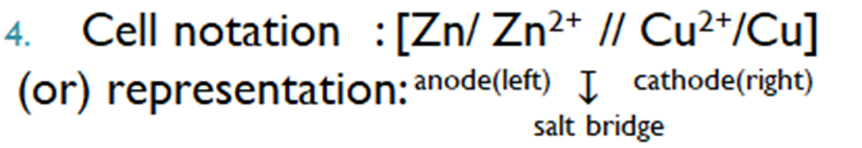
- Role of salt bridge:
- It prevents physical mixing of two Solutions
- It prevents the accumulation of changes around the electrode
- It allows the flow of current by completing the circuit
- It maintains the electrical neutrality of the solution.
Distinguish between electrolytic cell & galvanic cell:
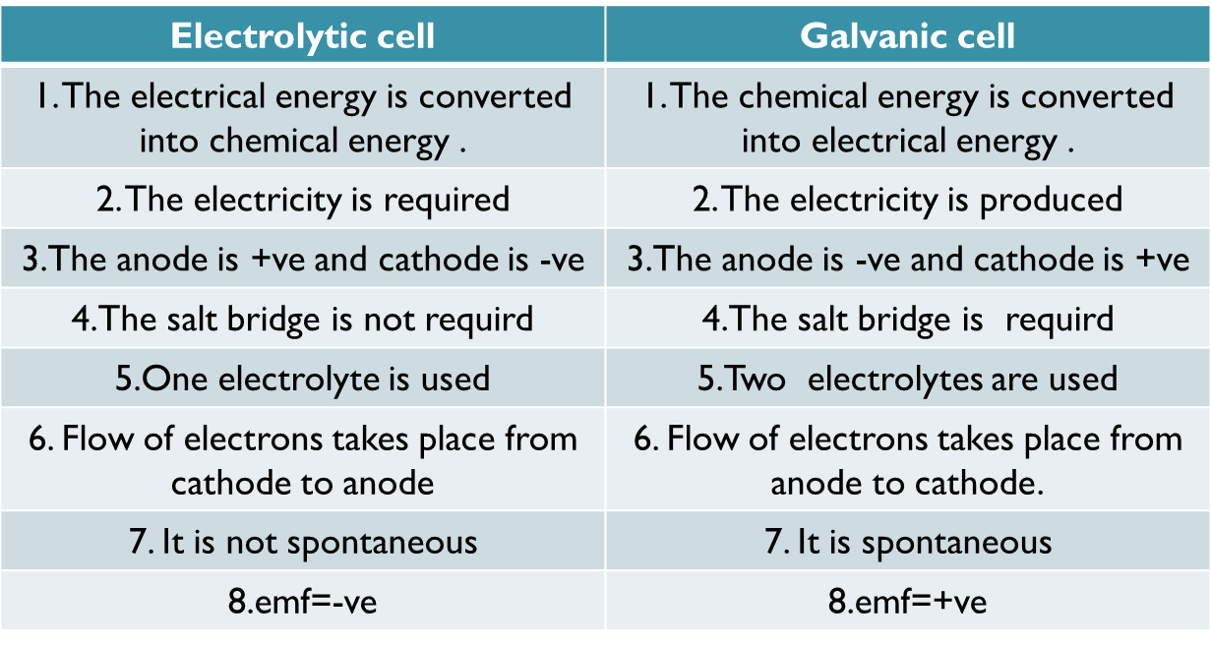
- Electrode Potential: The tendency of an electrode to loss (or) gain electrons is called electrode potential.
- These are two types.
- Oxidation potential: The tendency of an electrode to Loss electrons is called oxidation potential.
- Reduction potential: The tendency of an electrode to gain electrons is called reduction potential.
- STANDARD ELECTRODE POTENTIAL [Eº]: The tendency of an electrode of loss(or)gain electrons at 25°c with 1 molar concentration solution is called standard electrode potential .
- They are two types:
- STANDARD OXIDATION POTENTIAL[SOP]: The tendency of an electrode to loss electrons at 25ºC with 1 molar concentration solution is called standard oxidation potential [SOP]
- STANDARD REDUCTION POTENTIAL[SRP]:The tendency of an electrode to gain electrons at 25ºC with 1 molar concentration solution is called standard reduction potential [SRP]
- THE RELATION BETWEEN (SOP)&(SRP):
SOP = -SRP
ELECTRO CHEMICAL SERIES:
- The arrangement of metals in the increasing order of their standard reduction potential (SRP) is called electro chemical series.
- Significance:
- A metal which is top in electro chemical series can acts as reducing agents
- A metal which is lower in electro chemical series can acts as oxidising agents
- It can be used to understand the reactivity of metals
- It can be used to calculate the emf of galvanic cell.
- It can be used for metallurgical operations
- A metal which is top in electro chemical series can reacts with dilute acid to liberate H₂ gas
Ex: Zn + 2HCl ZnCl₂ + H₂ (↑)
- Electro motive force (emf): The potential difference between two electrodes of a galvanic cell is called emf
- It is denoted by “Eº_{cell}”
- emf(Eº_{cell} )=Eº_{cathode} - Eº_{anode}
^{(or)}
= Eº_{right} – Eº_{left}
- Units: volts
Importance:
- If emf of the cell is positive then the cell can generate electricity
- If emf of the is negative then cell cannot generate electricity
Problems:
- The standard reduction potential of “Zn” and “Cu” are -0.76 volts & +0.34volts respectively find the emf of cell (hint: [Zn/ Zn²⁺ (1M) // Cu²⁺ (1M) /Cu])
Solution: emf=?
given that , “Zn” is anode
“Cu” is cathode
emf(Eº_{cell} )=Eº_{cathode} - Eº_{anode}
= 0.34 – (-0.76)
= 0.34 + 0.76
= 1.10volts
Emf =1.1volts
Practice problems:
- Calculate the weight of zinc deposited when 4amperes of current is passed through a solution of ZnSO₄ for 30min?
- A current of 3amp passing through AgNO₃ Solution per 20min,deposits 4gm of silver. What is the electro chemical equivalent of silver?
- The standard reduction potential of “Zn” and “Cu” are -0.76 volts & -0.40volts respectively find the emf of cell. Does the cell function? (hint: [Zn/ Zn²⁺ (1M) // Cu²⁺ (1M) /Cu])

