METALLURGY
- Metallurgy : The branch of science which deals with the extraction of metals from their ores is Called metallurgy.
CHARACTERISTICS OF METALS:
- They are Solids at room temperature except "Hg".
- They are hard and strong.
- They have high density.
- They hove high M.P & B.P .
- They are good conductors of heat and electricity.
- They have “1” to “3” valency electrons.
- They form Cations .
- They have electro positive nature.
- They are good reducing agents.
- They have malleable & ductile properties.
- They form basic oxides.
Distinguish between metals & non-metals:
Metals | Non-metals
- They are Solids at room temperature except "Hg". | 1.They are solids (or) liquids (or) gaseous at room temperature.
2.They are hard and strong. | 2.They are soft and weak.
- They have high density | 3.They have low density
4.They have high M.P & B.P | 4.They have low M.P & B.P
5.They are good conductors of heat and electricity. | 5.They are bad conductors of heat and electricity.
6.They have “1” to “3” valency electrons. | 6.They have “4” to “7” valency electrons.
7.They form Cations . | 7.They form anions.
8.They have electro positive nature. | 8.They have electro negative nature.
9.They are good reducing agents. | 9.They are good oxidising agents.
10.They have malleable & ductile properties. | 10.They don’t have such properties.
11.They form basic oxides. | 11.They form acidic oxides.
Mineral: The natural compound of metal which is associated with earth impurities like as soil, sand, mud, etc.. is called mineral.
Ex: MgCO3 (Magnesite)
Cu2O (Cuprite)
Al2O3 . 2H2O (Bauxite)
- Ore: A metal which is extracted from the mineral is Called ore
- Ex:-NaCl , CaCO₃ , MgSO₄ , etc…
Gangue: The earth impurities present in the ore is called gangue.
- Ex: Soil , Sand, mud , etc….
Flux:- A Chemical substance which is added to remove the gangue is called flux.
- They are two types:
- Acidic flux:- It removes the basic impurities.
Ex: P₄O₁₀
- Basic flux :-It removes the acidic impurities
Ex-CaO.
- Slag: Flux reacts with the gangue to form a fusible product is called slag.
Ex: CaO + SiO₂ CaSiO₃
_{(FLUX) (GANGUE) (SLAG)}
- Concentration of ore: The process of removal of gangue from the ore is called Concentration of ore
- They are 3 types:
- Handpicking: This method is used when the ore and gangue are having difference in size, shape and colour
Ex: Hematite( Fe₂O₃)
WASHING (OR) LEVIGATION:
- PRINCIPLE : This method is used when the ore and gangue are having difference in density.
- In this method we can take a finely powdered ore into a tank .To this we can add water then the heavier ore particles are settle down at the bottom of tank . The light weight gangue are raised to top of tank and carried away with water.
- Ex: galena (PbS)
Froth flotation:
Principle:
- This method it based on the difference in the wetting properties of ore and gangue.
- This method is used for purification of sulphide ore.
- This method we can take a finely powder ore into a tank . To this add water and small amount of Pine oil , lime and Pottasium ethyl xanthate.
- Whole mixture is stirred vigorously by Passing compressed air to form forth.
- Ore particle are wetted by the oil and rise to the top tank
- The gangue are wetted by the water and will settle down at bottom of tank
- The ore particles are separated from the froth & washed with water to get Pure sulphide ore.
- Collector : potassium ethyl xanthate
activator : CuSO4
depresents : NaCN , KCN , etc….
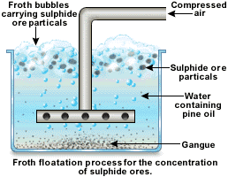
- Roasting:The Process of heating the ore, in the Presence of air below it’s melting point is called roasting.
- It can be used to remove volatile impurities.
- Ex-1: 2ZnS + 3O₂ -- ^{Δ} 2ZnO + 2SO₂ ↑
- Ex-2: 2FeS + 3O₂ -- ^{Δ} 2FeO + 2SO₂ ↑
CALCINATION: The Process of heating the ore, in the absence of air below it’s melting point is called calcination.
- It can be used to remove volatile impurities , moisture , organic impurities.
- Ex-1: CaCO₃ -- ^{Δ} CaO + CO₂ ↑
- Ex-2: ZnCO₃ -- ^{Δ} ZnO + CO₂ ↑
Smelting: The process of heating the ore in the presence of reducing agent (C_{coke}) to form molten metal is called smelting.
- Ex-1: ZnO + C_{coke} -- ^{Δ} Zn + CO ↑
^{(MOLTEN METAL)}
- Ex-2: PbO + C_{coke} -- ^{Δ} Pb + CO ↑
^{(MOLTEN METAL)}

Difference between roasting and calcination:

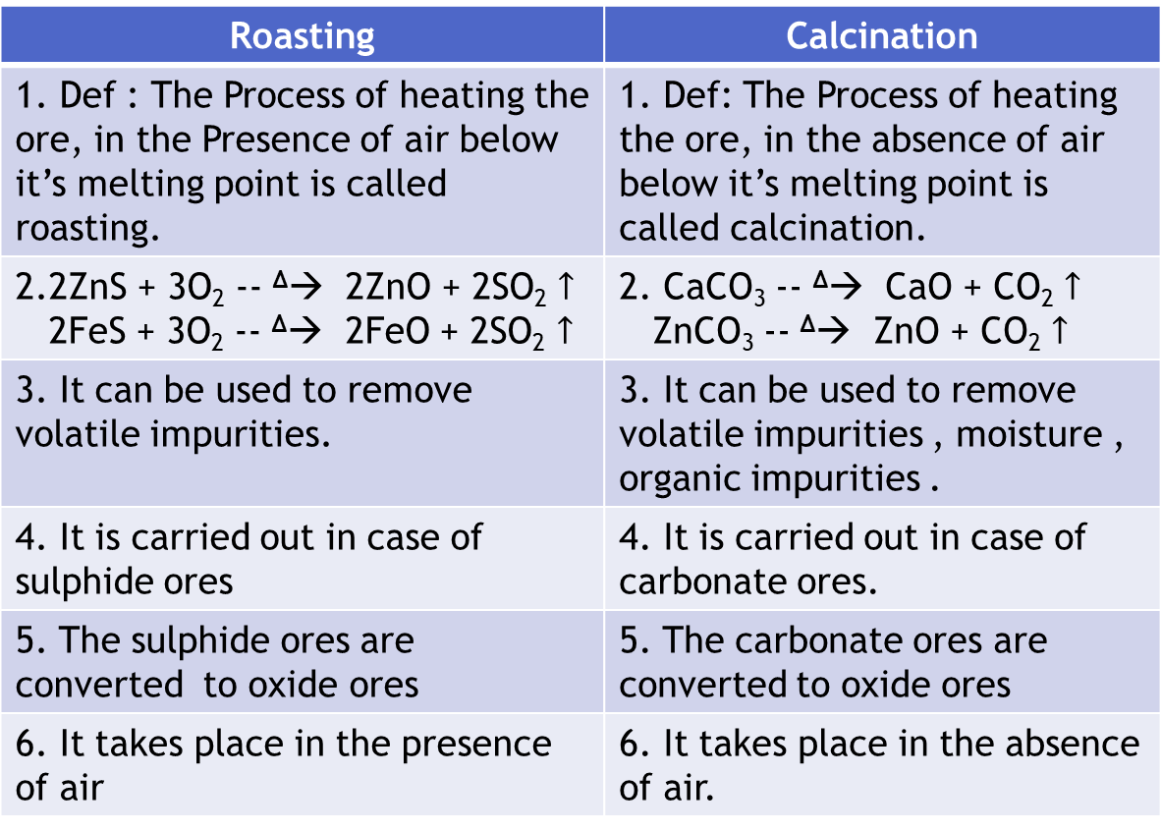
Electrolytic refining process:
- Def: The process of removal of impurities from impure metal to get pure metal by electrolysis is called electrolytic refining process.
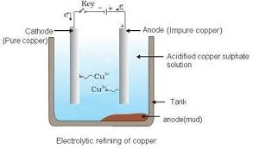
- Anode: impure copper metal
- Cathode: pure copper metal
- Electrolyte: acidified CuSO₄.
- REACTIONS:
- Ionisation: CuSO₄ ⇌ Cu²⁺ + SO₄²⁻
- At anode: Cu Cu₂⁺ + 2e- (oxidation)
- At cathode: Cu²⁺ + 2e- Cu (reduction)
Alloys: The homogenous mixture of two or more elements with metalic properties is called alloys.
- Properties:
- They are harder than metals.
- They are less reactive.
- They are more corrosive in resistance.
- They have low M.P.
Compositions and uses of alloys:
BRASS:
- Composition: Cu(60% - 70% )
Zn(30% - 40%)
- Uses:
- It is used for making of decorative articles, screws. handles , etc..
- It is used for making of parts of watches , machinery parts , etc…
German silver:
- Composition: Cu ( 50% )
Zn (30% )
Ni ( 20% )
- Uses:
- It is used for making of decorative articles , electric heaters , etc.
- It is used for making of resistors , rheostats , etc….
Nichrome:
- Composition: Ni ( 60% )
Cr ( 15% )
Fe ( 25% )
- Uses:
- It is used for making of resistors , heating coils , etc…
- It is used for making of resistance wires , etc…

