ACIDS AND BASES
PROPERTIES OF ACIDS:
- They are sour to taste.
- They turn blue litmus to red.
- They react with base to form salt and water.
- They are corrosive in nature.
- They are good conductors of heat and electricity
PROPERTIES OF BASES:
- They are bitter to taste.
- They turn red litmus to blue.
- They react with acid to form salt and water.
- They are soapy nature to touch.
- They are good conductors of heat and electricity.
ARRHENIUS THEORY OF ACIDS AND BASES:
It was proposed by Arrhenius in 1887.
- Acid: A substance which gives H⁺ ions in aqueous solution is called an acid
Ex: HCl , H₂SO₄ , etc..
- Base: A substance which gives OH⁻ ions in aqueous solution is called a base
Ex: NaOH , KOH , etc…
- Neutralization: The process of acid reacts with base to form salt and water is called as neutralization.
Ex: HCl + NaOH NaCl + H₂O
(acid) (base) (salt) (water)
- Limitations:
- This theory only applicable for aqueous solution.
- It cannot explain the acidic nature of CO₂ , SO₂ , etc…
- It cannot explain the basic nature of NH₃ , CaO , etc….
BRONSTED LOWRY THEORY OF ACIDS AND BASES:
- It was proposed by Bronsted Lowry in 1923.
- It is also known as proton theory of acids and bases.
- Acid: A substance which can donate a proton is called acid.
Ex: HCl , H₂SO₄ , etc..
- Base: A substance which can accept a proton is called base
Ex: H₂O , NH₃ , Cl⁻ , Br⁻ , etc…
- Neutralization: The process of transfer of proton from acid to base to form conjugate acid and conjugate base is called neutralization.
Ex-1: HCl + H₂O ⇌ H₃0⁺ + Cl⁻
(acid) (base) (conj. acid) (conj.base)
Ex-2: NH₃ +HCl ⇌ NH₄⁺ + Cl⁻

- Limitations:
- It cannot explain the acidic nature of CO2 , SO2 , etc…
- It can not explain the basic nature of Cao, BaO , etc…
- It cannot explain the neutralization of CO₂ and CaO.
Ex: CO₂ + CaO CaCO_{3.}
LEWIS THEORY OF ACIDS AND BASES:
- It was proposed by lewis in 1923.
- Acid: A substance which can accept the electron pair and forms co-ordinate covalent bond is called acid.
Ex: BF₃ , AlCl₃ , etc…
- Base: A substance which can donate the electron pair and forms co-ordinate covalent bond is called base.
Ex: NH₃ , H₂O , Cl⁻ , Br⁻ , etc…
- Neutralization: The process of co-ordinate covalent bond formed between acid and bases is called neutralization.
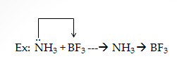
- Limitations:
- It cannot explain the acids HCl , H₂SO₄ , HNO_{3 ,} etc…
- It cannot explain the strengths of acids and bases.
- Generally acid-base reactions are fast , but lewis acid-base reactions are slow.
- IONIC PRODUCT OF WATER: The product of molar concentration of H⁺ and OH⁻ ions at any temperature of aqueous solution is called ionic product of water.
- It is denoted by “K_{w}”
- K_{w} = [H⁺ ] [OH⁻]
- K_{w} = 1 x 10⁻¹⁴ moles²/litre² at 25ºC
- Significance:
- If [H⁺ ] = [OH⁻] then the solution is neutral.
- If [H⁺ ] > [OH⁻] then the solution is acidic.
- If [H⁺ ] < [OH⁻] then the solution is basic.
- Note:
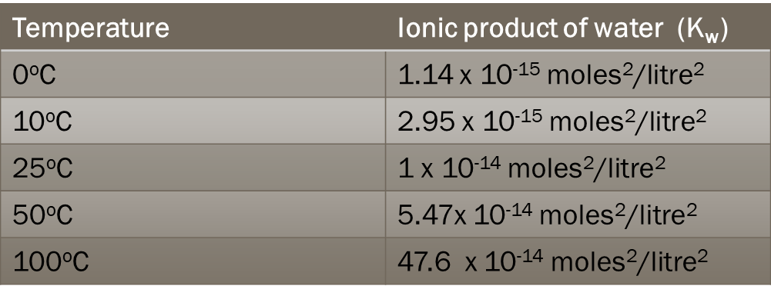
- P^{H} : The negative logarithm of concentration of H⁺ ion is Called P^{H}
- P^{H} = -log [H⁺ ]
- P^{H} – scale (or) S.P.Sorenson scale:
- It was proposed by S.P.Sorenson.
- The range of P^{H} is “0” to “14”.
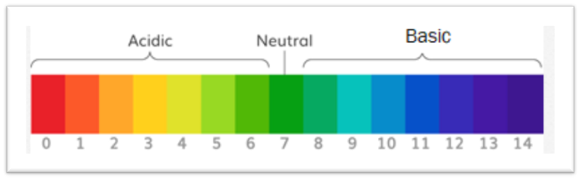
- Significance:
- For acidic solutions : P^{H}<7.
- For basic solutions : P^{H}>7.
- For neutral solutions : P^{H}=7.
- Importance of P^{H} :
- Blood has o Specific P^{H} (i.e,7.35) ,and this always be maintained.
- Crops requires soils of specific P^{H} (i.e,7) for good yields.
- Many analytical procedures takes place at specific P^{H.}
- Biological processes and Industrial processes takes Place at specific P^{H.}
PROBLEMS:
- Formulae:
- P^{H} = -log [H⁺ ] (For acids)
- P^{OH} = -log [OH⁻ ] (For bases)
- P^{H} + P^{OH} = 14.
- [H⁺ ] = 10^{- PH}
- Note:
- log(a x b) = log a + log b.
- log a^{n} = n x log a.
- log1=0.
- log10=1.
Model-1:
- Find the P^{H} of 0.05M H₂SO₄ .
Ans: P^{H} = -log [H+ ]
given that , [H+ ] = 0.05M
= 5/100 = 5/10²
= 5 x 10^{-2.}
basicity = 2
[H+ ] = 5 x 2 x 10⁻²
= 10 x 10⁻²
[H+ ] =10⁻¹
Since , P^{H} = -log [H+ ]
= -{log(10⁻¹ ) }
=-{-1 x log10}
= -{ -1 x 1}
= -{-1}
= 1.
- Find the P^{H} of 0.01N HNO₃ .
Ans: P^{H} = -log [H+ ]
given that , [H+ ] = 0.01N
= 1/100 = 1/10²
= 1 x 10^{-2.}
[H+ ] = 1 x 10⁻²
Since , P^{H} = -log [H+ ]
= -{log(1 x 10⁻² ) }
=-{log1 + log 10⁻²} (log(a x b) = log a + log b )
= -{ 0 + log 10⁻² } (log an = n x log a)
= -{-2 log10} (log10=1)
= -{-2}
=2.
Model-2:
- Calculate the P^{H} of 0.001M NaOH.
Ans: P^{OH} = -log [OH⁻ ]
given that , [OH⁻ ] = 0.001M
= 1/1000=1/10³
[OH⁻ ] = 1 x 10^{-3.}
acidity =1
[OH⁻ ] = 1 x 1 x 10^{-3.}
[OH⁻ ] = 1 x 10^{-3.}
since, P^{OH} = -log [OH⁻ ]
= -{log(1 x 10⁻³ ) }
=-{log1 + log 10⁻³} (log(a x b) = log a + log b )
= -{ 0 + log 10⁻³ } (log an = n x log a)
= -{-3 log10} (log10=1)
= -{-3}
P^{OH} =3.
Since, P^{H} + P^{OH} = 14.
P^{H} = 14 - P^{OH}
= 14 – 3. = 11.
Model-4:
- P^{H} of a solution is 6.58 . Calculate the hydrogen ion concentration in the solution.
Ans: [H+ ] = ?
given that , P^{H} = 6.58.
since , [H⁺ ] = 10^{- PH}
= 10 ^{-6.58}
[H⁺ ] = 2.630 x 10^{- 7.} moles / lit.
- Buffer solution: A Solution whose p^{H} does not changes by adding small amount of strong acid (or) strong base is called buffer solution.
- Types:- They are two types
- Acidic buffer solution: A solution which contains weak acid and strong basic salt is called acidic buffer solution.
Ex-1:- CH₃COOH +CH₃COONa
Ex-2:- H₂CO₃+ NaHCO₃
- Basic buffer solution:-A solution which contains weak base and strong acidic salt is called basic buffer solution.
Ex-1:-NH₄OH + NH₄Cl
Ex-2:- Cu(OH)₂ + CuSO₄
APPLICATIONS (OR) USES:
- They are used in water-softening process.
- They are used in tonics and Syrups.
- They are used in agriculture and dairy Products
- They are used in Fermentation Process.
- They are used in Bio-chemical reactions.
- They are used in chemical and industrial purpose.
- Conjugate acid-base pair: A pair of acid- base differ by a single proton is called conjugate acid- base pair.
Ex-1:- HCl , Cl⁻
Ex-2:- H₃0⁺ , H₂O
Ex-3:- NH₄⁺ , NH₃
Ex-4:- HNO₃ , NO₃⁻ , etc….
- Types of lewis acids: They are 3 types.
- Simple cations:- Ex: H⁺ , Na⁺ , Mg²⁺ , etc..
- Molecules:- Ex: BF₃ , BCl₃ , AlCl₃ , etc..
- Molecules containing double bonds:- Ex:CO₂ , SO₂ , NO₂ , etc…
Types of lewis bases:
- They are 3 types.
- Simple anions:- Ex: OH⁻ , Cl⁻ , Br ⁻ , etc..
- Molecules:- Ex: NH₃ , H₂O , etc..
- Molecules containing multiple bonds:- Ex:C₂H₄ , C₂H₂ , etc…
INNOVATIVE PROBLEMS:
- 4gm of NaOH are dissolved in 1lit of solution . Calculate the P^{H} of solution .
Ans: P^{H} = ?
P^{OH} = -log [OH⁻ ]
Given that , Wt = 4gm
G.Eq.Wt of NaOH = G.M.Wt of NaOH / Acidity
G.M.Wt Of NaOH = Na+ O + H
=23+16+1
= 40gm
Acidity = 1.
G.Eq.Wt of NaOH = 40 / 1 = 40gm.
, Normality= Wt. x 1000
G.Eq.Wt V_{ml}
= 4 x 1000
40 1000
= 1/10
[OH⁻ ] = 10⁻¹
since, P^{OH} = -log [OH⁻ ]
= -{log(10⁻¹ ) }
=-{ log 10⁻¹}
= -{-1 log10} (log an = n x log a)
= -{-1 log10} (log10=1)
= -{-1}
P^{OH} =1.
Since, P^{H} + P^{OH} = 14.
P^{H} = 14 - P^{OH}
= 14 – 1. = 13.
PRACTICE PROBLEMS:
- Find the P^{H} of 0.001M HCl.
- Find the P^{H} of 0.02N H₂SO₄ .
- Calculate the P^{H} of 0.002M Ba(OH)₂ .
- If a solution has P^{H} of 5.81 at 25ºC. calculate the H⁺ ion concentration
O.365gm of HCl is dissolved in 1lit of water . Calculate the P^{H} of solution

