SOLUTIONS
- Solution:- The homogenous mixture of two (or) more substances is called solution.
Ex:- glucose solution , sugar solution , etc….
- Solute:- The substance present in smaller quantity in a solution is called solute.
Ex:- glucose , sugar , salt , etc….
Solvent:- The substance present in larger quantity in a solution is called solvent.
Ex:- water,…
Classification of solution on the basis of physical state:
- The solutions are classified into three types on the basis of physical state.
- Gaseous solutions: These are three types
- Gas in gas:- Ex: H₂ & O₂ mixture , air , etc…
- Liquid in gas:- Ex: water in air , etc….
- Solid in gas:- Ex: dust in air , etc…
- Liquid solutions: These are three types
- gas in Liquid:- Ex: soda water , etc….
- Liquid in Liquid:- Ex: alcohol in water , etc…
- Solid in liquid:- Ex: salt in water , etc…
- Solid solutions: These are three types
- Gas in Solid:- Ex: “H₂” gas in “Ni” , etc….
- Liquid in solid:- Ex: “Hg” in “Zn” (amalgam) , etc..
- Solid in solid:- Ex: alloys , etc…
Mole: The substance which contains avogadro’s number (6.023x10²³) of particles is called mole.
It is denoted by “n”.
Ex-1: “23gm” of “Na” = 1 mole.
Ex-2: “16gm” of “O” = 1 mole.
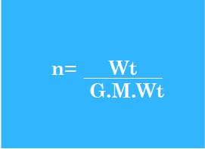
Formulae:-1) n = Wt / G.M.Wt.
2) Wt = n x G.M.Wt.
- Units: moles.
Problems:
Model-1:-
Find the number of moles present in 32 grams SO₂
Ans: n=?
Given that , Wt = 32gm
G.M.Wt of SO₂ = S + 2(O)
= 32 + 2(16)
= 64gm.
since, n = Wt / G.M.Wt
= 32 / 64.
= 1/2.
= 0.5moles]
- Find the number of moles present in 1Kg of NaOH.
Ans: n=?
Given that , Wt = 1Kg = 1000gm.
G.M.Wt of NaOH = Na + O +H
= 23 + 16 + 1
= 40gm.
since, n = Wt / G.M.Wt
= 1000 / 40.
= 25moles.
Model-2:-
- Calculate the weight of 0.2moles of CaCO₃.
Ans: Wt=?
Given that , n=0.2moles.
G.M.Wt of CaCO₃ = Ca + C + 3(O)
= 40 + 12 + 3(16)
= 40 + 12 + 48
= 100gm.
since , Wt = n x G.M.Wt.
= 0.2 x 100
= 20gm.
- Atomic weight:- the number of times of an atom is heavier than 1/12th of weight of ¹²C atom is called atomic weight.
Ex-1: The atomic weight of “N” = 14.
Ex-2: The atomic weight of “O” = 16.
- Molecular weight:- The sum of atomic weights of all atoms present in a molecule is called molecular weight.
Ex: HCl
M.Wt = H + Cl
= 1 + 35.5
= 36.5gm
- Equivalent weight:- The amount of substance that reacts with 1gm Hydrogen (or) 8gm of Oxygen (or) 35.5gm of Chlorine is called equivalent weight.
Ex: HCl
Eq.Wt of “Cl” = 35.5/1
= 35.5gm.
NOTE:
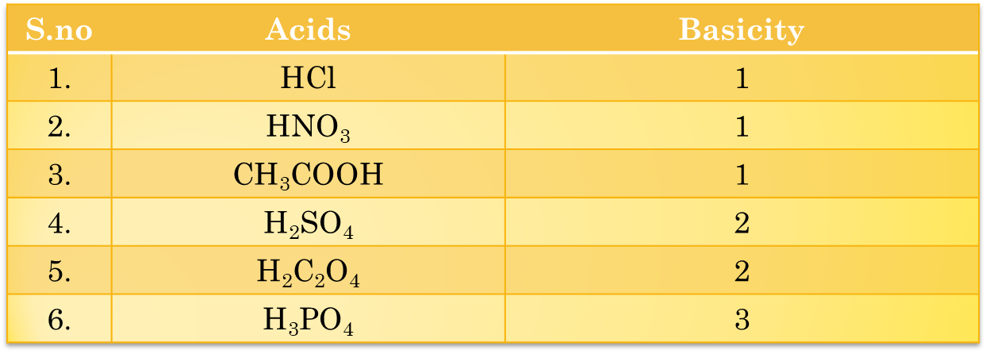
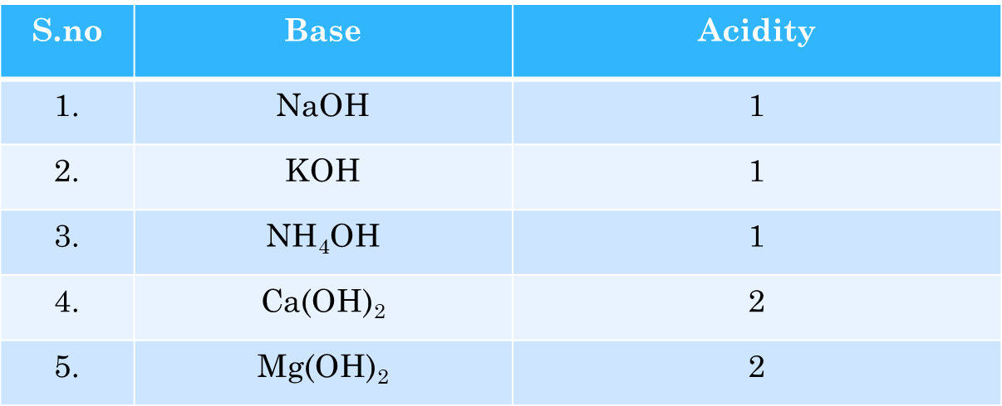

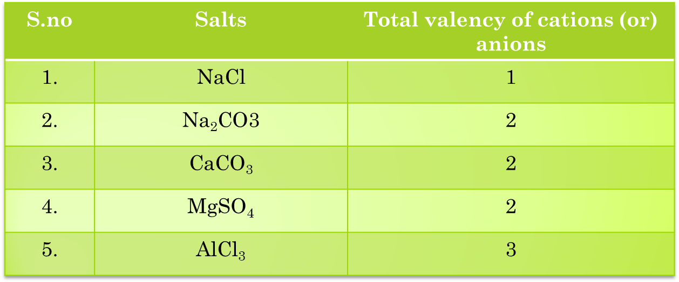
Calculation of equivalent weight of given acids , bases and salts:
- Acids :
- Equivalent weight of acids: The ratio of G.M.Wt of acids to its basicity is called Eq.Wt of acids.
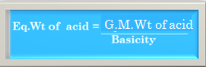
Basicity: The number of replaceable hydrogen atoms present in an acid is called basicity .
Ex: HCl
Eq.Wt of HCl = G.M.Wt of HCl / Basicity.
G.M.Wt of HCl = H + Cl = 1 + 35.5 = 36.5
Basicity = 1
Eq.Wt of HCl = 36.5 /1
= 36.5gm
Bases:-
Eq.Wt of bases: The ratio of G.M.Wt of bases to it’s acidity is called Eq.Wt of bases.
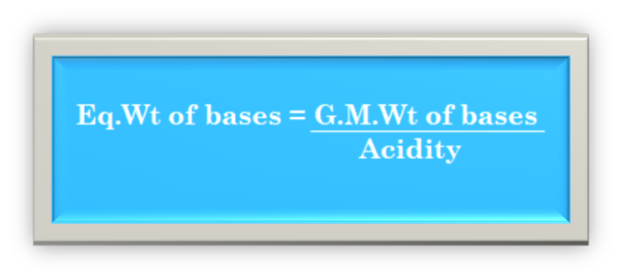
Ex:
Acidity : The number of replaceable “OH” groups present in a base is called acidity.
Ex: KOH
Eq.Wt of KOH = G.M.Wt of KOH / Acidity.
G.M.Wt of KOH = K + O + H = 39 + 16 + 1 = 56
Acidity = 1
Eq.Wt of KOH = 56 / 1 = 56gm

Bases:-
Eq.Wt of bases: The ratio of G.M.Wt of bases to it’s acidity is called Eq.Wt of bases.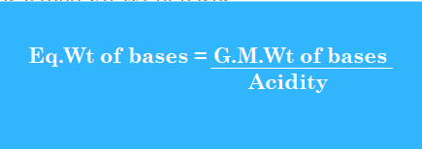
Acidity : The number of replaceable “OH” groups present in a base is called acidity.
Ex: KOH
Eq.Wt of KOH = G.M.Wt of KOH / Acidity.
G.M.Wt of KOH = K + O + H = 39 + 16 + 1 = 56
Acidity = 1
Eq.Wt of KOH = 56 / 1 = 56gm.
Salts :-
Eq.Wt of salts: The ratio of G.M.Wt of salts to it’s total valency of cations (or) anions is called Eq.Wt of salts.
Eq.Wt of salts = G.M.Wt of salts
total valency of cations (or) anions
Ex: Na₂CO₃ G.Wq.Wt = 53gm

Ex: NaCl
Eq.Wt of salts = G.M.Wt of salts / total valency of cations (or) anions
G.M.Wt of NaCl = Na + Cl = 23 + 35.5 = 58.5gm
total valency of cations (or) anions = 1
Eq.Wt of salts = 58.5 / 1 = 58.5gm
Molarity : The number of moles of solute present in 1liter of solution is called molarity
- It is denoted by “M”
M = Wt. x 1000
G.M.Wt V_{ml}
Units: M (or) moles/lit
FORMULAE:
- M = Wt. x 1000
G.M.Wt V_{ml}
- Wt. = M x G.M.Wt x V_{ml} / 1000
- M = n x 1000 / V_{ml}
- For dilute solution : M₁V₁ = M₂V₂
PROBLEMS:-
MODEL-1:
- Calculate the molarity of solution containing 2gm of NaOH dissolved in 250ml of solution .
Ans: Given That, Wt = 2gm.
volume (v) = 250ml
G.M.Wt Of NaOH = Na+ O + H
=23+16+1
= 40gm
Since , M = Wt. x 1000
G.M.Wt V_{ml}
= 2 x 1000
40 250
= 0.2M
MODEL-2:
- Calculate the weight of NaOH present in 250ml of 0.1M solution
Ans: Given that, Molarity(m) =0.1M.
volume (v) =250ml·.
G.M.Wt of NaOH = Na + O + H
= 23 + 16 + 1
= 40gm
Since, Wt. = M x G.M.Wt x V_{ml} / 1000
= 0.1 x 40 x 250 / 1000
= 1gm

MODEL-3:
- 100ml of 0.05M solution contains how many moles of the solute
Ans: n =?
given that , Molarity (M) = 0.05M
Volume (V) =100ml
Since , M = n x 1000 / V_{ml}
n = M x V_{ml} / 1000
= 0.05 x 100 /1000
= 0.005 moles
MODEL-4:
- 100ml of 0.5M Solution is diluted to 1 liter of solution . Calculate the molarity of dilute solution.
Ans: Given that , M₁=0.5M.
V₁ = 100ml.
V₂ =1litre =1000ml.
M₂= ?
Since, For dilute solutions :M₁V₁ = M₂V₂
0.5 x 100 = M₂ x 1000
M₂ = 0.5 x 100 / 1000
= 0.05M
Calculate the volume of water to be added to l00ml of 0.2M HCl Solution to get 0.1m HCl solution.
Ans: Given that , M₁=0.2M.
V₁ = 100ml.
M₂ =0.1 M
V₂= ?
Since, For dilute solutions :M₁V₁ = M₂V₂
0.2 x 100 = 0.1 xV₂
V₂ = 0.2 x 100 / 0.1
= 200ml
The volume of water to be added (V) = V₂ - V₁
= 200 - 100
= 100ml
Normality: The number of gram equivalents of solute present in 1litre of solution is called Normality.
- It is denoted by “N”.
N = Wt. x 1000
G.Eq.Wt V_{ml}
- Units : N
FORMULAE:
- N = Wt. x 1000
G.Eq.Wt V_{ml}
- Wt. = N x G.Eq.Wt x V_{ml} / 1000
- For dilute solution : N₁V₁ = N₂V₂
PROBLEMS:-
MODEL-1:
- Find the normality of solution prepared by dissolving 10gm NaOH in 500ml of water.
Ans: N=?
Given That, Wt = 10gm. .
volume (v) = 500ml
G.Eq.Wt of NaOH = G.M.Wt of NaOH / Acidity
G.M.Wt Of NaOH = Na+ O + H
=23+16+1
= 40gm
Acidity = 1.
G.Eq.Wt of NaOH = 40 / 1 = 40gm.
Since , N = Wt. x 1000
G.Eq.Wt V_{ml}
= 10 x 1000
40 500
= 0.5 N
MODEL-2:
1.Calculate the weight of HCl present in 500ml of 0.1N
Ans: Given that, normality (N)=0.1N
volume (v) = 500ml
G.Eq.Wt of HCl = G.M.Wt of HCl / basicity
G.M.Wt of HCl = H + Cl
= 1+35.5
= 36.5gm
basicity = 1
G.Eq.Wt of HCl = 36.5 / 1 = 36.5gm
Since , Wt. = N x G.Eq.Wt x V_{ml} / 1000
= 0.1 x 36.5 x 500 / 1000
= 1.825gm
MODEL-3:
- 500ml of 0.2N solution is diluted to 1lit calculate the normality of dilute solution.
Ans: Given that , N₁=0.2M.
V₁ = 500ml.
V₂ =1litre =1000ml.
N₂= ?
Since, For dilute solutions : N₁V₁ = N₂V₂
0.2 x 500 = M₂ x 1000
M₂ = 0.5 x 500 / 1000
= 0.1M
PRACTICE PROBLEMS:
Molarity:
- Calculate the molarity of 10% NaOH
- Find the weight of urea (NH₂CONH₂) is required to prepare 2litre of 0.2M solution.
- 500ml of 0.02M solution contains how many moles of the solute.
- 500ml of 0.1M Solution is diluted to 1000ml of solution . Calculate the molarity of dilute solution.
- Normality:
- Calculate the normality of Na₂CO₃ solution containing 10.6g/lit
- Calculate the weight of oxalic acid (H₂C₂O₄ . 2H₂0) required to prepare 0.05N solution in 2litre
- Calculate the normality of 20ml of NaOH that exactly neutralize to 50ml 0f 0.02N H₂SO₄
MOLARITY & NORMALITY:
- Calculate the molarity and normality of solution is prepared by dissolving 10.6gm Na₂CO₃ in 500ml of water

