FUNDAMENTALS OF CHEMISTRY

Chemical bonding
- Chemical bond : The force of attraction between two atoms in a molecule is called chemical bond.
- Significance:
- Atoms combine to form molecules to get stability.
- Atoms have high energy and less stable
- Molecules have less energy and more Stable.
- “The Stability of atoms due to the presence of eight electrons in the valency Shell is called octet rule”.
- Nobel gas elements are stable due to ns² np⁶ configuration.
Electronic theory of valency:-
- Postulates:-
- It was proposed by Lewis and kossel in 1916.
- A Chemical bond is formed In between the atoms with the help of valency electrons.
- A Chemical bond is formed in between the atoms by transfer (or) Sharing of electrons takes place.
- “The Stability of atoms due to the presence of eight electrons in the valency Shell is called octet rule”.
- Nobel gas elements are stable due to ns² np⁶ configuration.
- Ionic bond (or) electrovalent bond:- It was proposed by kossel.
- Def: The electrostatic force of attraction between two oppositively charged ions by the transfer of electron is called ionic Bond.
Ex:- NaCl , MgO , etc…
Formation of ionic bond in Nacl(sodium chloride):-
- The “Na” atom lose “1” electron to get stability and form “Na⁺” ion.
Na -------------- Na⁺ + e⁻
- The “Cl” atom gain “1” electron to get stability and form “Cl⁻” ion.
Cl + e⁻ ----------- Cl⁻
- The Na⁺ and Cl⁻ combine to form NaCl.
Na⁺ + Cl⁻ --------- NaCl
Formation of ionic bond in MgO (Magnesium Oxide):-
- The “Mg” atom lose “2” electron to get stability and form “Mg²⁺” ion.
Mg ----------- Mg²⁺ + 2e⁻
- The “O” atom gain “2” electron to get stability and form “O2⁻” ion.
O + 2e⁻ -------- O²⁻
- The Mg²⁺ and O²⁻ combine to form MgO.
Mg²⁺ +O²⁻ --------- MgO
PROPERTIES OF IONIC COMPOUNDS:
- They are crystalline solids.
- They are soluble in polar solvents like H₂0
- They are formed by transfer of electrons
- They are good conductors of heat and electricity.
- These reactions are fast.
- They have high M.P & B.P
They don’t exhibit Isomerism
Covalent bond:-
- It was proposed by lewis
- Def : A chemical , bond formed by mutual Sharing of electrons between two atoms is called Covalent bond.
- Ex :- H₂ , O₂ , N₂ , HCl , HF ,etc…..
- A Covalent bond formed between two similar atoms is called non-polar Covalent bond.
Ex:- H₂ , O₂ , N₂ , etc..
- A Covalent bond formed between two different atoms is called polar Covalent bond.
Ex:- HCl , HF ,etc…..
- It is denoted by “-”.
Lewis dot method (or) electron (e-) dot method:-
FORMATION OF COVALENT BOND IN H₂:
Thus , each hydrogen atom share ‘1’ electron and form single bond between two hydrogen atoms
Formation of covalent bond in O2:-
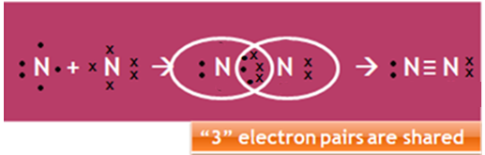
Thus , each oxygen atom shared “2” electrons and form double bond between two oxygen atoms.
Formation of covalent bond in N₂:-

Thus , each nitrogen atom share “3” electrons and forms “triple bond” between two nitrogen atoms.
Properties of covalent bond:-
- They are Solids (or) liquids (or) gaseous.
- They are soluble in Non-polar Solvents like alcohol, benzene etc..
- They are formed by mutual sharing of electrons.
- They are bad Conductors of heat and electricity·
- These reactions are slow .
- They have low M.P & B.P .
- They exhibit Isomerism.

Distinguish between ionic compounds & covalent compounds:-
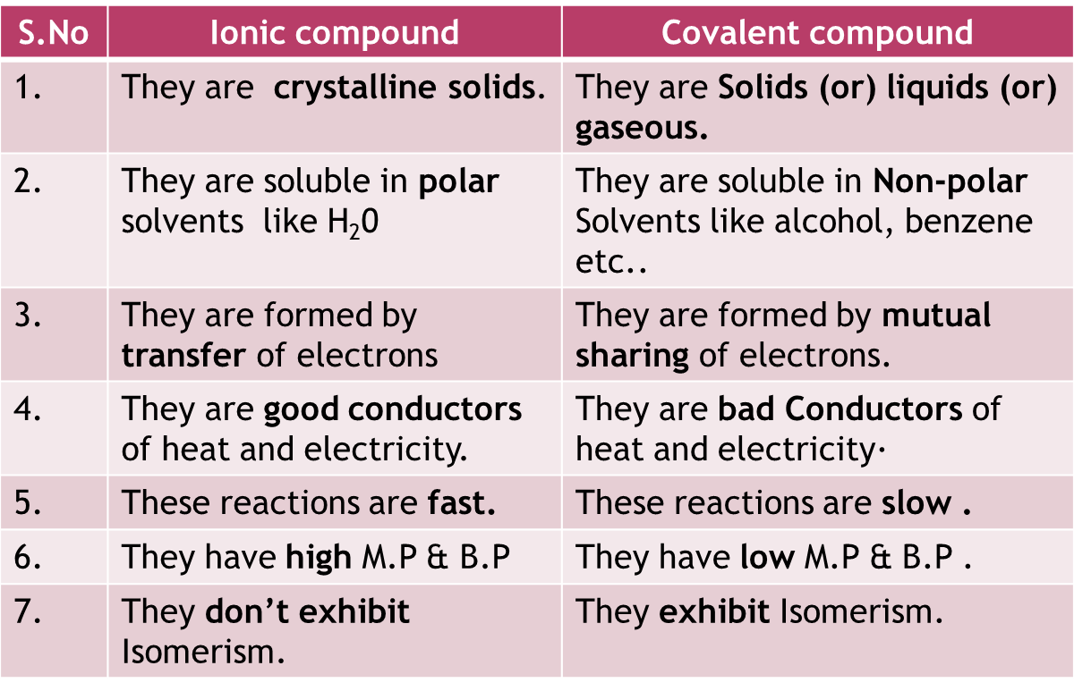
Structure of ionic solid:-
Unit cell:- The smallest part of crystalline solid which represents the structure of crystal is called unit cell.
Co-ordination number:- the number of oppositively charged ions present around an ion is called co-ordination number.
Ex-1:- The co-ordination number in NaCl is “6”
Ex-2:- The co-ordination number in MgO is “8”
Structure of unit cell of NaCl:-
- The co-ordination number in NaCl is “6”
- Each Na⁺ ion is surrounded by “6” Cl⁻ ions and each Cl- ion is surrounded by “6” Na⁺ ions.
- The structure of unit cell of NaCl is FCC(Face Centered Cubic).
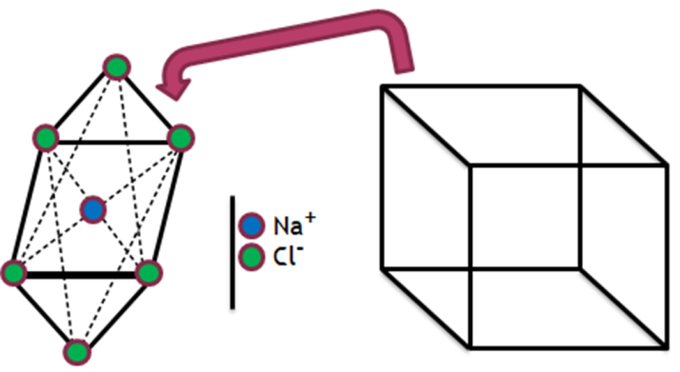
Structure of unit cell of CsCl:
- The co-ordination number in CsCl is “8”
- Each Cs⁺ ion is surrounded by “8” Cl⁻ ions and each Cl⁻ ion is surrounded by “8” Cs⁺ ions.
- The structure of unit cell of CsCl is BCC(Body Centered Cubic).
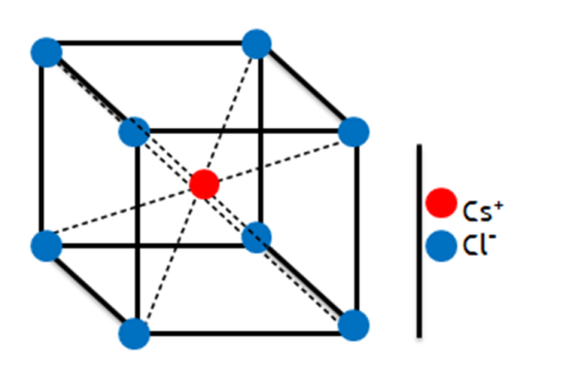

- Oxidation:-The process of removal of electrons from an atom is called oxidation.
- Ex:- Na---- Na⁺ +e⁻
- Reduction:- The process of addition of electrons to an atom is called reduction.
- Ex:- Cl + e⁻ --- Cl⁻
- Oxidation number (or) oxidation state :- The charge actually present in an atom is called oxidation number.
- Ex-1:- Na⁺ oxidation number = +1
- Ex-2:- Cl⁻ oxidation number = -1
- Valency (or) valency number :- The number of electrons are involved in bonding is called valency.
- Ex-1:- The valency of “O” is 2.
- Ex-2:- The valency of “N” is 3.
- Difference between oxidation number and valency :
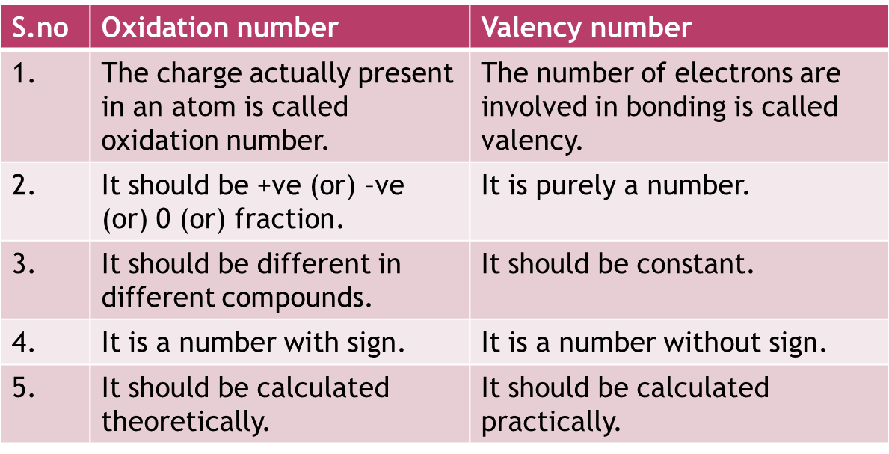
Calculation of oxidation number:-
Note :
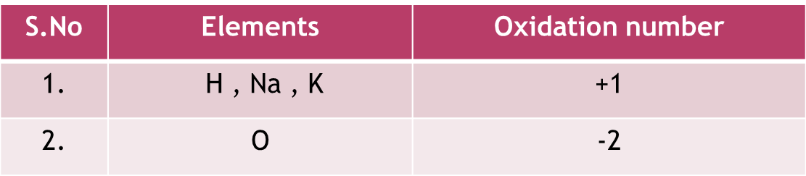
Rules:-
- The sum of oxidation number of all atoms in a neutral molecule is equal to “0”.
- The sum of oxidation numbers of all atom in a charged ion is equal to it’s charge.
Model-1:
Find the oxidation number of “S” in H₂SO₄.
Ans: Let , the oxidation number of “S”= x
Since , H₂SO₄
2(H) + S + 4(O) = 0
2(1) + x + 4(-2) = 0
2 + x – 8 = 0
x – 6 = 0
x= +6
Model-2:
Find the oxidation number of “Cl” in ClO₄.
Ans: Let , the oxidation number of “Cl” = x
since , ClO₄
Cl + 4(O) = -1
x + 4(-2) = -1
x – 8 = -1
x = -1 + 8
x = +7.

Practice problems:

